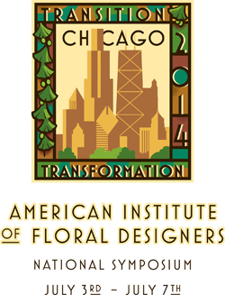
Calling all Energetic, Hardworking, and Creative Designers!

Have you ever wondered. . .
What it takes to make all that MAGIC happen at Symposium?

Or. . . Are you a “Work Room Veteran” ready to jump right back into the fray?

Whatever the case we invite you all to apply for a volunteer position at this year’s “Transition Transformation” Symposium in Chicago, Illinois. As the 2014 Volunteer Coordinators, we are excited about providing a positive rewarding volunteer experience for each of you! We will need volunteers beginning on June 29th through July 8th in order to make all the magic happen! As many of us know from personal experience the AIFD symposium can be life changing for designers; providing inspiration, instilling unparalleled education, and building professional relationships that alter careers.

Your Volunteer Coordinators
Laura L. Parker AIFD, CF Email: laura_parker821@yahoo.com Cell: 248-245-5348
Carolyn Kurek AIFD Email: Coralcay2@aol.com Cell:317-590-8165

How exciting to take part in making all of this come together!
Join us by sending the following information to: laura_parker821@yahoo.com

VOLUNTEER CONTACT DATA
Name:
Address:
City:
State/Region: Postal Code: Country:
Email:
Primary Phone:
Optional Secondary Phone:
*One phone must be cell phone for reaching you once we are in Chicago
A little Information about your experience and design skills/credentials:
*So we can try to match you with projects that will give you the best volunteer experience!

